Metabase BI Dashboard Widget

Summary
Metabase dashboard from within iDempiere's home page and via dedicated windows. Metabase has the ability to share dashboards via iframe.

Dedicated Window
iDempiere has the ability to show an iFrame in a window/form. Here is an example. We need the ability to show a metabase dashboard via a window without creating a new plugin every time. Here is an example:
- User creates a new metabase dashboard
- User creates a new iDempiere menu item and points the menu item to the appropriate URL
- User uses the existing Role => Form Access to determine what roles can see the specific dashboard
We have add a URL field to the System => Form window to support loading the correct dashboard.

Homepage Widget
We need to be able to easily consume these dashboards in iDempiere's home page for any given role. Said another way, I need to be able to add a given Metabase dashboard to a given iDempiere role without creating a new plugin every time. Any given role might have multiple metabase dashboards; therefore, we need to be able to show multiple dashboard widgets.

Setting up metabase as a quick test is easy
- Download the jar
- Run the jar on a system with java installed. You can run it with H2 (default) or postgres (what I do) to hold Metabase configuration. This page has all the details you need.

Configure Dashboard entry in Form
- Login as System
  - Creates a new Metabase Form from Form Window
    - set metabase dashboard URL in Form => URL field.
    - Classname: com.logilite.metabaseBI.form.WCustomFormController
    - Dashboard Number: Reference of metabase dashboard for direct zoom [ Optional ]
  - Need to run Role Access Update process after Database Form creation.

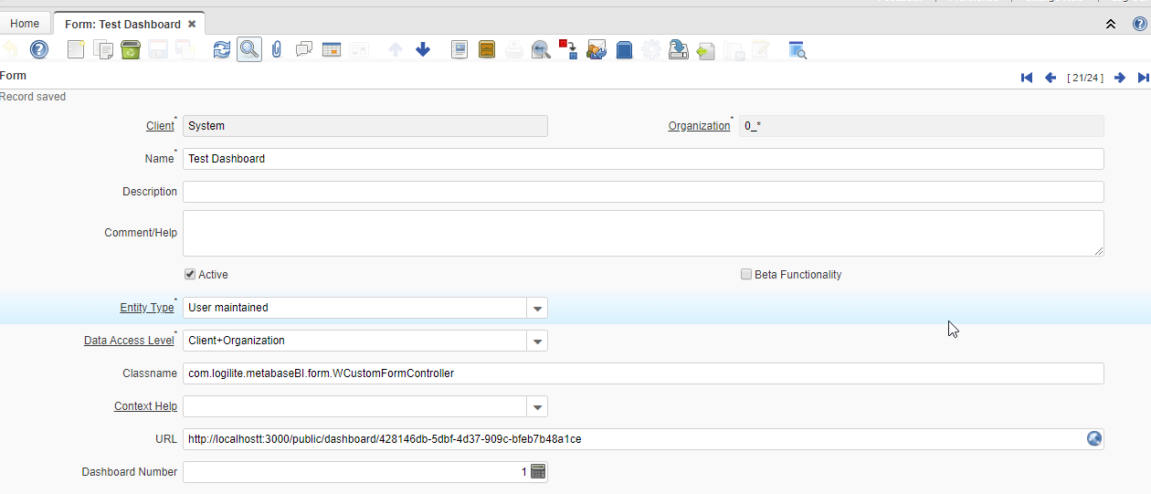
- Logout and Re-Login as Tenant or System, widget will be shown

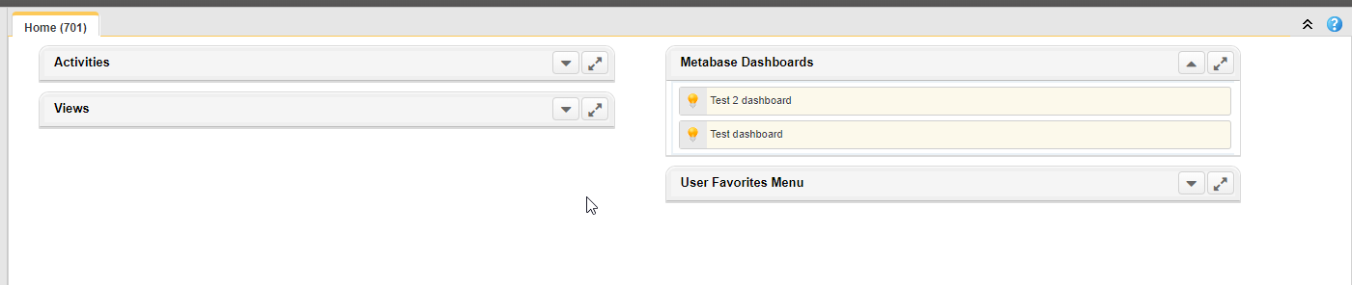

**Note : Only those forms is shown on Dashboard which has access in Role Window ==> Form access Tab.

Show URL in Form window:
- Client wise System configurator: METABASEUI_SHOW_URL [ default true ]
  - Value should be true / false / Y / N / y / n

Dashboard Number
- In System => Form window to field called "Dashboard Number" (integer) in addition to the URL (reason for this change in the next bullet)
- Metabase Form => URL field to use:
  - http://localhost:3000/dashboard/8 (see below bullets for details)
  - Where 8 is the "Dashboard Number" as observed from the URL when editing a dashboard in metabase.
  - Reasons for change:
    - Publicly published dashboards to not allow a user to zoom into data
    - Even when you log in, using the hashed link version of the dashboard (http://localhost:3000/public/dashboard/f4d07207-cf19-4166-a8b6-b49fec151f14) does not allow you to zoom into data.
    - It is not until you are (a) logged in and (b) navigated to the dashboard that you can zoom in on data.
  - Change the URL text field to include a Zoom button to make navigating to the dashboard easier.
  - NOTE: if the user does not have a metabase username/password, they will not be able to do anything. That is OK for now. Eventually, we will update Metabase to use single sign on.

